**Qualitative Analysis**

**Companies**

1. AUROBINDO PHARMA LTD
2. DIVI'S LABORATORIES LIMITED
3. BIOCON LIMITED
4. DR. REDDY’S LABORATORIES LTD
5. CADILA HEALTHCARE

**Analysis**

|  |  |
| --- | --- |
| **Aurobindo Pharma Brand Analysis** | |
| **Parent Company** | **Aurobindo Pharma** |
| **Category** | Pharmaceutical |
| **Sector** | [**Pharma and Healthcare**](https://www.mbaskool.com/brandguide/pharmaceuticals-and-healthcare.html) |
| **Tagline/ Slogan** | Committed to healthier life! |
| **USP** | Among the largest 'Vertically Integrated' pharmaceutical companies in India, with a robust product portfolio |
|  | |
| **Aurobindo Pharma STP** | |
| **Aurobindo Pharma Segmentation** | CVS, Antibiotics, Gastroenterologicals, Anti-Diabetics , Anti-Allergic Anti-Retroviral and CNS |
| **Aurobindo Pharma Target Market** | Patients and doctors who seek good health |
| **Aurobindo Pharma Positioning** | They are global pharmaceutical company with great commitment to healthier life |
| **Aurobindo Pharma SWOT Analysis** | |
| **Aurobindo Pharma Strengths** | Below are the Strengths in the SWOT Analysis of Aurobindo Pharma:  1. A new drug Nevirapine discovered against the HIV infective disease has been approved by the US FDA, which will increase the market size and profits of the company.  2. Approval of generic version of Clopidogrel from FDA will boost revenue of company  3. A greater growth in terms of sales in the US and Europe due to various US approvals  4. Strong marketing network 5. Aurobindo exports to over 125 countries across the globe |
|  | |
| **Aurobindo Pharma Weaknesses** | Here are the weaknesses in the Aurobindo Pharma SWOT Analysis:  1. Retirement of the three top most directors will have an impact on the functioning till new capable people join.  2. The company is not into mergers or acquisitions which will help it increase the product list  3. Very low in the corporate social front  4. Largely dependant on Indian market for revenue generation |
| **Aurobindo Pharma Opportunities** | Following are the Opportunities in Aurobindo Pharma SWOT Analysis:  1. Increasing health awareness  2. improving the R&D section to expand the product pipeline  3. Globalize and further break through into joint ventures and subsidiaries into China, Brazil and other Latin American markets. |
| **Aurobindo Pharma Threats** | The threats in the SWOT Analysis of Aurobindo Pharma are as mentioned:  1. The European crisis, which will have a great impact on the sales since major orders are from the Europe and US  2. Depreciating value of currency will affect the export  3. Peers post a major competition. |

|  |  |
| --- | --- |
| **Dr.Reddy's Brand Analysis** | |
| **Parent Company** | **Dr.Reddy's Laboratories Ltd** |
| **Category** | Pharmaceuticals |
| **Sector** | [**Pharma and Healthcare**](https://www.mbaskool.com/brandguide/pharmaceuticals-and-healthcare.html) |
| **Tagline/ Slogan** | Life.  Research.  Hope |
| **USP** | Strong vertically integrated portfolio of products, businesses & geographies |
|  | |
| **Dr.Reddy's STP** | |
| **Dr.Reddy's Segmentation** | Active Pharmaceutical Ingredients (APIs), Custom Pharmaceutical Services (CPS), generics, biosimiler, differentiated formulations and News Chemical Entities (NCEs) |
| **Dr.Reddy's Target Market** | Healthcare professionals, retail outlets |
| **Dr.Reddy's Positioning** | Committed to providing affordable and innovative medicines for healthier lives |
| **Dr.Reddy's SWOT Analysis** | |
| **Dr.Reddy's Strengths** | Below are the Strengths in the SWOT Analysis of Dr.Reddy's:  1. Company launched Peg-grafeelTM, an inexpensive variety of pegfilgrastim, used to fight infection in chemotherapy where company has sold some 1.5 million units of it. 2. Dowpharma/Chirotech acquisition provided proprietary chiral and biocatalysis technology 3.The acquisition of Beta pharma helped to introduce an array of generic products and show its presence in the European markets. 4. Has a strong workforce of over 15,000 employees |
|  | |
| **Dr.Reddy's Weaknesses** | Here are the weaknesses in the Dr.Reddy's SWOT Analysis:  1. Discovery of drugs is a highly unpredictable business 2. Strict govt regulations and policies affects operational efficiency |
| **Dr.Reddy's Opportunities** | Following are the Opportunities in Dr.Reddy's SWOT Analysis:  1. Leverage Biologics & Cytotoxic Infrastructure to deal with the need of Oncology Market 2.New partnerships to develop Biosimiler business 3. Develop cost effective ways of new drug development to improve business in emerging markets |
| **Dr.Reddy's Threats** | The threats in the SWOT Analysis of Dr.Reddy's are as mentioned:  1.Preliminary investment for Drug discovery is very high  2. long gestational period for new drug development  3. increasingly stringent regulations for new drug development |

|  |  |
| --- | --- |
| **Cadila Healthcare Brand Analysis** | |
| **Parent Company** | **Cadila Healthcare** |
| **Category** | Pharmaceuticals |
| **Sector** | [**Pharma and Healthcare**](https://www.mbaskool.com/brandguide/pharmaceuticals-and-healthcare.html) |
| **Tagline/ Slogan** | The care continues |
| **USP** | An integrated healthcare solutions provider, catering to over 45 therapeutic segments. |
| **Cadila Healthcare STP** | |
| **Cadila Healthcare Segmentation** | Respiratory agents, cardiovascular, haematinics, gastrointestinal, analgesics, anti-infective and antibiotics, anti- diabetics and immunological. |
| **Cadila Healthcare Target Market** | Diagnostic, preventive and curative pharmaceutical and diagnostic product seeking healthcare professionals |
| **Cadila Healthcare Positioning** | Marketing of the pharma products to assuage, identify and thwart diseases. |
| **Cadila Healthcare SWOT Analysis** | |
| **Cadila Healthcare Strengths** | Below are the Strengths in the SWOT Analysis of Cadila Healthcare:  1.USFDA approved plant for clinical trials  2.Sole manufacturer in Indian of Streptokinase and Hyaluronic Acid-based products  3. Caters to over 45 therapeutic areas and has presence in over 90 countries  4. Cadila has acquired Bio-chem which is major player in anti-infective segment in domestic market  5. Recommercialisation of Urokinase through partnership with Microbix |
|  | |
| **Cadila Healthcare Weaknesses** | Here are the weaknesses in the Cadila Healthcare SWOT Analysis:  1. Tough competition means the market share is limted  2. Weak international presence compared to a few international brands |
| **Cadila Healthcare Opportunities** | Following are the Opportunities in Cadila Healthcare SWOT Analysis:  1. Large penetration strategies in the therapeutic market to increase the market share  2. increasing prevalence of chronic diseases such as diabetes, cancer  3. Penetration of medical insurance |
| **Cadila Healthcare Threats** | The threats in the SWOT Analysis of Cadila Healthcare are as mentioned:  1. Debt in the foreign currency and weak rupee may cause MTM  2. Economic fluctuations and emergence of global players 3. Govt policies and restrictions in the medical field |

**BIOCON Limited**

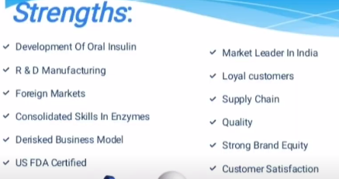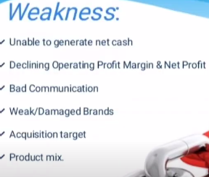

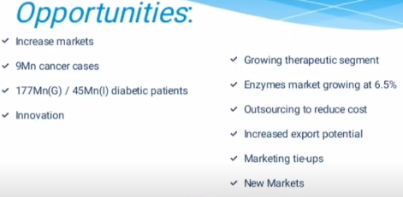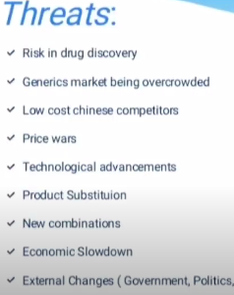

**DIVIS LABORATARIES**

**Revenue Model**

**Product Wise Breakup**

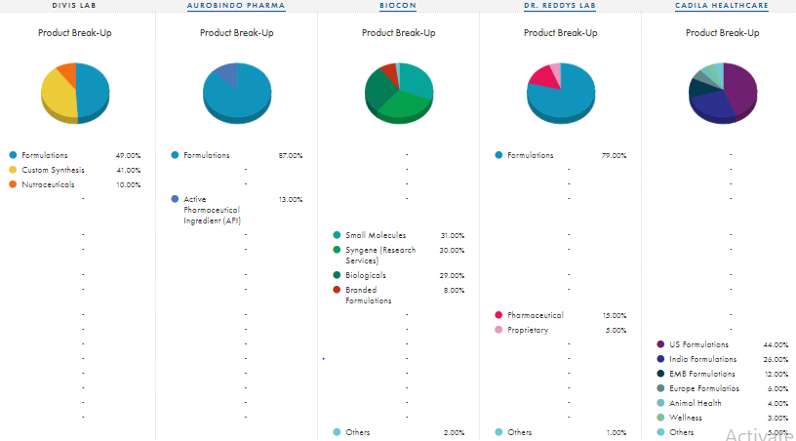

**Location Wise Breakup**

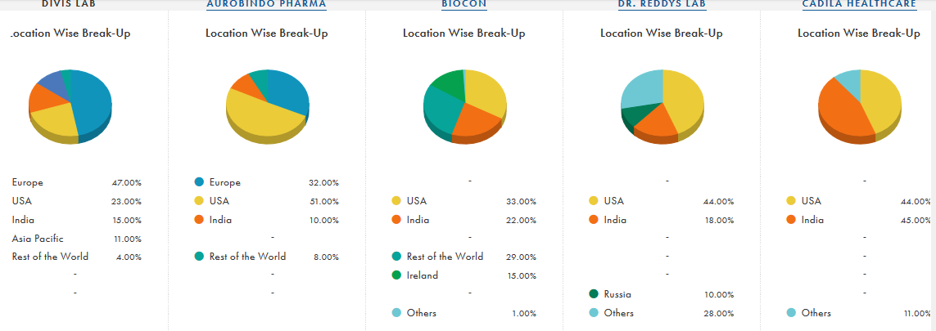

**Returns**

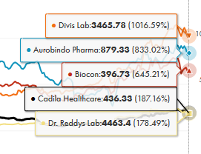 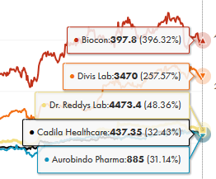

**10 Year 5 Year**

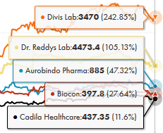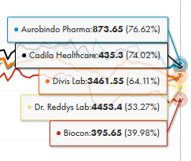

**3 Year 1 Year**

**Market Share**

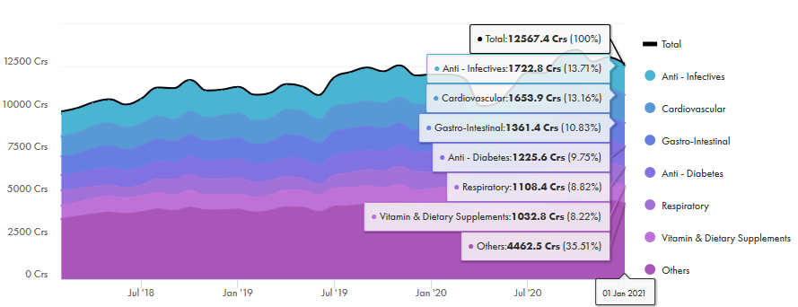

**Domestic Pharma**

* ***Aurobindo Pharma***

38%

Hepatitis B Medication (Entecavir)

36%

Gastrointestinal Medication (Pantoprazole Sodium)

33%

Kidney Medication (Sevelamer Carbonate OS)

31%

Anti-Viral Medication (Valganciclovir)

28%

Anti-Infective Medication (Piperacillin - Tazobactam)

28%

Anti-Infective Medication (Cefixime OS)

25%

Anti-Depression Medication (Duloxetine)

22%

ADHD Medication (Atomoxetine)

17%

Kidney Medication (Sevelamer Carbonate)

5%

Gastro-Intestinal Medication (Esomeprazole)

* ***DIVI'S LABORATORIES LIMITED***

70%

Naproxen and Cough Suppressant

* ***BIOCON LIMITED***

1.8%

Anti - Diabetes

75%

Insugen

50%

Orlistat API

27%

CANMAb

21%

Pegfi Igrastim Syringes

30%

Trastuzumab

* ***DR. REDDY’S LABORATORIES LTD***

5.1%

Gastro-Intestinal

2.7%

Cardiovascular

2%

Domestic Pharmaceutical

2.8%

Pharmaceutical Sector

1.9%

Anti - Diabetes

1.6%

Anti-Infectives

1.9%

Vitamin & Dietary Supplements

* ***CADILA HEALTHCARE***

94%

Artificial Sweetener (Sugar Free Natura)

34%

Face Wash (Everyuth Scrub)

4.5%

Cardiovascular

4%

Gastro-Intestinal

3.4%

Pharmaceutical Sector

3.3%

Anti-Infectives

1.1%

Vitamin & Dietary Supplements

0.7%

Anti - Diabetes

**Management Analysis**

* AUROBINDO PHARMA LTD

|  |  |
| --- | --- |
| **Name** | **Designation** |
| **K Nithyananda Reddy** | **Vice Chairman & Whole Time Dir** |
| **M Madan Mohan Reddy** | **Whole Time Director** |
| **M Sivakumaran** | **Whole Time Director** |
| **N Govindarajan** | **Managing Director** |
| **P Sarath Chandra Reddy** | **Whole Time Director** |

Aurobindo Pharma, its promoter PV Ramprasad Reddy, his wife P Suneela Rani, and three other entities have settled an alleged insider trading case with markets regulator Sebi after paying over Rs 22 crore towards settlement charges.

* DIVI'S LABORATORIES LIMITED

Sebi finds Divis Lab CFO, son, 6 others guilty of insider trading; fines them Rs 97 lakh

* BIOCON LIMITED

Siddharth Mittal: CEO and Managing Director

KIRAN MAZUMDAR SHAW: Executive Chairperson

We will continue to invest in and grow our portfolio of differentiated Active Pharmaceutical Ingredients (APIs)

Over the next five years, we aim to continue to leverage our strengths in **fermentation technology** and characterization techniques to build on this vertically integrated pipeline in the niche formulations space. The strategy is to build a robust pipeline of difficult-to-make, technology-intensive molecules which can be commercialized

* DR. REDDY’S LABORATORIES LTD

Mr.K Satish Reddy: Chairman

Mr.G V Prasad: Co-Chairman & Manag. Director

* CADILA HEALTHCARE

Pankaj R Patel: Chairman

Sharvil P Patel: Managing Director

**Regulation**

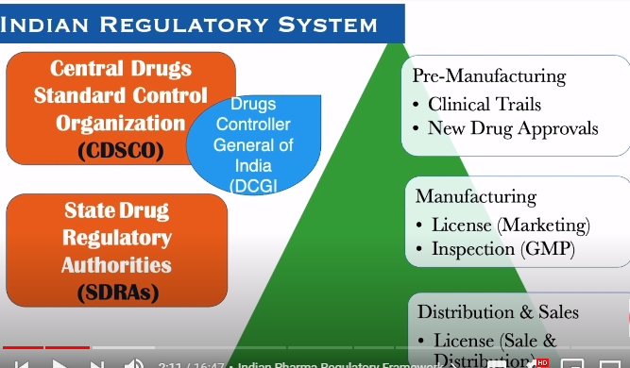

Aurobindo’s 11 units for APIs / intermediates and 15 units (10 in India, 3 in USA, 1 in Brazil and 1 in Portugal) for formulations are designed to meet the requirements of both advanced as well as emerging market opportunities.

Aurobindo Pharma is among the largest filers of DMFs and ANDAs in India.

The Company has accelerated the DMF/ANDA filings programme in its efforts to build a broad product portfolio for the regulated markets. Cumulatively the Company has filed a total of 337 DMFs (Drug Master Files) of which 110 are with US FDA and 133 in Europe including with the EDQM and 102 in other countries. This is one of the highest filings.

Founded in 1986